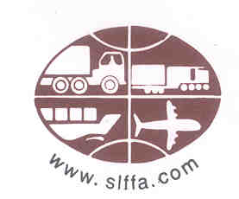

SRI LANKA FREIGHT FORWARDERS ASSOCIATION

TRAINING & EDUCATION REPORT

For

32nd Executive Council Meeting

Of

The Federation of Asia Pacific Air-cargo Associations

In

Udaipur, India

03rd – 04th June 2005

TRAINING & EDUCATION PROGRAMS

The Association is mindful of the developments taking place in the international Freight forwarding arena and continue to keep the Sri Lanka freight forwarding industry abreast with the rest of the world. The Association is working towards raising standards within the industry and making the industry a dynamic and more responsive trade sector. Thus, the Association is heading human resource development within the industry through international training programs for members.

For the third consecutive year, the Association in collaboration with the Australian Federation of International Forwarders (AFIF) conducted a full DGA course, which was held from 14th – 17th February 2005 for member companies with the participation of 22 participants for the DGA course and 10 participants for the DGR Refresher course. The training program helped member companies to improve their competence of handling dangerous cargo in concurrence with IATA standards. The Association has requested AFIF to conduct an IATA accredited Basic & Advanced Airfreight course, and AFIF has informed SLFFA that they are currently in the process of receiving IATA accreditation from IATA Singapore for the Basic & Advanced Airfreight training program.

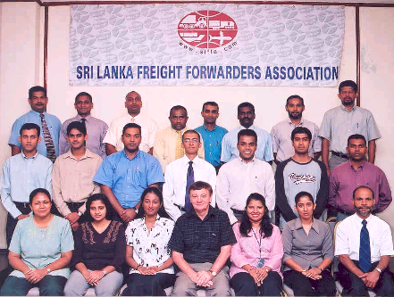
(Participants for the SLFFA – AFIF DGA/DGR Refresher Course held
from 14th – 17th February 2005, in Colombo, Sri Lanka. Seated 4th from
left, Mr. Bob Rogers, Trainer from AFIF)

SLFFA is currently having discussions with the CINEC Maritime Campus in Sri Lanka, on organizing numerous IATA accredited training programs to be conducted on a regular basis. The Association and CINEC are in the process of drafting a suitable MOU, which would be finalized shortly.

